WORKSHOP: SAVE OUR PLANET AND ANIMAL IN DANGER
Name: _________________________________ grade:__________
lee el texto y responde las preguntas
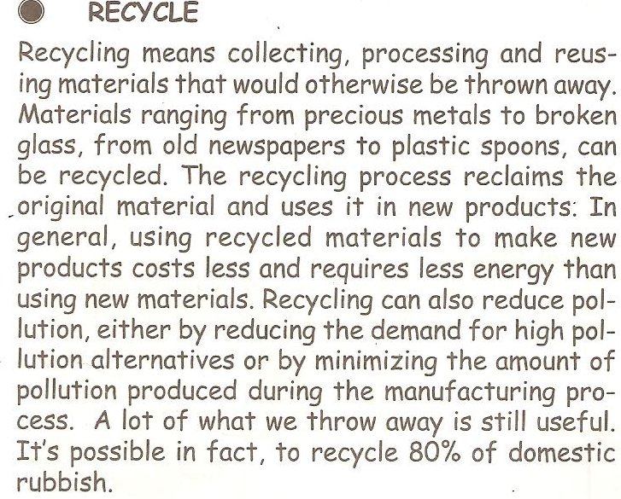

- How can we help to keep our environment clean?
- What kind of materials can be recycled?
- What can you do with material you recycle at home or at school?
- How does recycling help the environment?
- Why is it important to save energy and water?
- What are some of the things people can do to save water?
- What are some of the things people can do to save energy?
- Why shouldn’t we use aerosol products?
- What happen to water when we throw away garbage?

2. Fill in the crossword puzzle choosing from the box the word that corresponds to the definition given below, and write it in the grid.

Rainforest – save – reuse – recycle – fossil fuel Extinct – pollutants – methane - disposable

1. Container or material that you can throw away after the first use.
2. We do this when we use old things to make new ones.
3. Non-renewable resource of energy.
4. This gas among others produces the greenhouse effect.
5. We need to do this with energy if we want to have some in the future
6. Term used to define extensive areas of trees in the tropics.
7. This means to use some thing again.
8. Elements that contaminate the environment.
9. This word means that a plant or an animal has disappeared completely from the surface of the Earth.
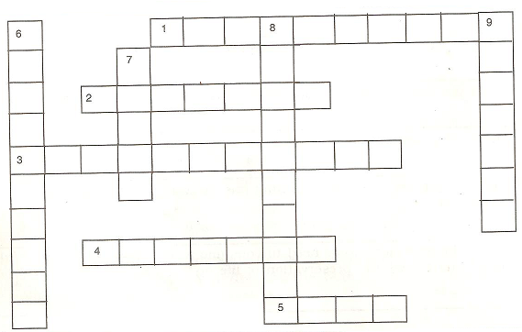

3. Choose the words that best complete the sentences. You can use each word only once

Garbage – fossil fuels – last – danger – sun
Fertilizers – recycle – energy – save – efficient
Activity – earth – water – problem – responsible
Cleaning – trees – reuse – clean - rainforests

The ____________ is in grave _______________ as a result of human _____________.
The destruction of__________________, the use of __________________, the burning of _________________ and the pollution of the _______________ are some of the main ______________ that are affecting our planet. Since we have been __________________ for polluting the atmosphere, we should be responsible for_________________ it up. When we ___________________ paper and cardboard we help to reduce the amount of ___________________ cut in the rainforests. Also if we _______________ containers, we can keep lots of _________________ away from rivers, lakes, and oceans, thus keeping the water ____________________.
Furthermore, if we ____________________ energy and reduce the consumption of fossil fuels, we can make them ________________ longer. In the meantime, scientists can develop forms of __________________ that are cleaner and more __________________ such as energy from the _______________, the wind and under the ground.

