EJRCICIO DE REFUERZO 2DO PERIODO – THERE IS/ARE – HOW MUCH/MANY- SOME/ ANY
NAME: ___________________________________________ GRADE: 7° DATE:_______
- Make an inventory of the picture. Use there is – there are. See the example.
Example: there is a fan on the ceiling
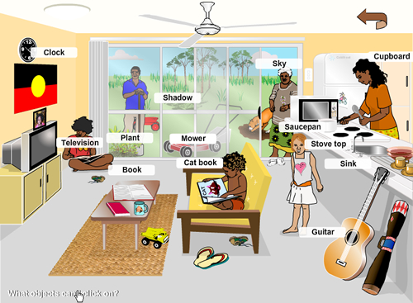
2. THERE IS / THERE ARE
A. Complete the sentences using "there is" or "there are".
1. ______________books on the table.
2. _____________ many cars in the street.
3. ______________ a picture on the wall.
4. . _____________ _pencil near the book.
5. ______________many trees in the forest.
6. ______________ a cat under the table.
7. ______________seven apples in the fridge.
8. ______________ a dog in the house.
9. ______________ a monkey on the tree.
10. ______________ many rooms in my house. stars are there in the sky?
B. Complete the sentences using "Is there" or "Are there".
1. ______________an opera in our city?
2. ______________ many girls in your class?
3. ______________ a police-station near the hospital?
4. ______________ any bananas in the basket?
5. ______________ trees in the park?
C. Complete the sentences using "there isn't" or "there aren't".
1. ______________many people in the streets.
2. ______________any butter in the fridge.
3. ______________ any plates on the table.
4. ______________ any milk in the bottle.
5. ______________any coffee in the cup.
D. Complete the sentences using "there is" / "there are" / "is there" / "are there" / "there isn't" / "there aren't".
1. ______________someone looking at me.
2. ______________many boys in the school?
3. ______________some photos in her bag.
4. ______________ any eggs in the fridge.
5. ______________ any magazine in her room.
6. ______________any soccer stadium here?
. USE HOW MUCH OR HOW MANY
A. ____________ people live on islands?
B. ____________birds are there?
C. ____________ water is there in the ocean?
D. ____________money is there in a bank?
E. ____________countries are there in the world?
F. ____________ bread is eaten per day?
G. ____________ bones are there in the human body?
H. ____________sand is there in the deserts?
I. ____________ information is there on the internet?

4. Complete using some/any/a/an:

1. There's airport next to the city.
2. There are beautiful gardens, but there aren't fountains.
3. There are postcards on this table for you.
4. Are there parents in that party?
5. There isn't shopping centre in this little town.
6. Is there office near here?
7. There are good books that you should read.
8. Is there orange in the fridge?
9. Are there chocolates in the kitchen?
10. There aren't cookies left, sorry!
11. There's house next to the river. Some friends live there.
12. Are there armchairs in your house?

