HOMEWORK: Giving the time
- Put the time into the clock
- It is eleven o’clock
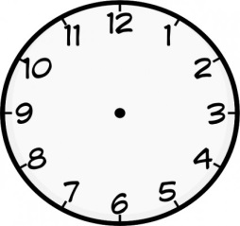
- It six and a quarter
- It is twenty five past five
- It twenty to nine
- It is ten to four

- Write the time in the clocks

